**FINAL EXAM:**

**Part 1 – Vocabulary Terms:**

Instructions: Define in 2-3 sentences in space below word, use examples if / when possible. Small example sketch in box on right is optional for extra credit.

1) Manuport

|  |  |
| --- | --- |
|  |  |

2) Lamassu

|  |  |
| --- | --- |
|  |  |

3) Hieroglyphic

|  |  |
| --- | --- |
|  |  |

4) Composite View

|  |  |
| --- | --- |
|  |  |

5) Canon

|  |  |
| --- | --- |
|  |  |

6) Fresco

|  |  |
| --- | --- |
|  |  |

7) Linear Perspective

|  |  |
| --- | --- |
|  |  |

8) Mosaic

|  |  |
| --- | --- |
|  |  |

9) Illuminated Manuscript

|  |  |
| --- | --- |
|  |  |

10) Constantine

|  |  |
| --- | --- |
|  |  |

**Part 2 – Slide Identification:**

Instructions: Identify the major information about each of these slides (*Title, Date, Location, Material, Artist*). Optionally, discuss historical or cultural significance for extra credit in the space labelled *Extra Information*.

11)

|  |
| --- |
| Extra Information (Extra Credit): |

12)

|  |
| --- |
| Extra Information (Extra Credit): |

13)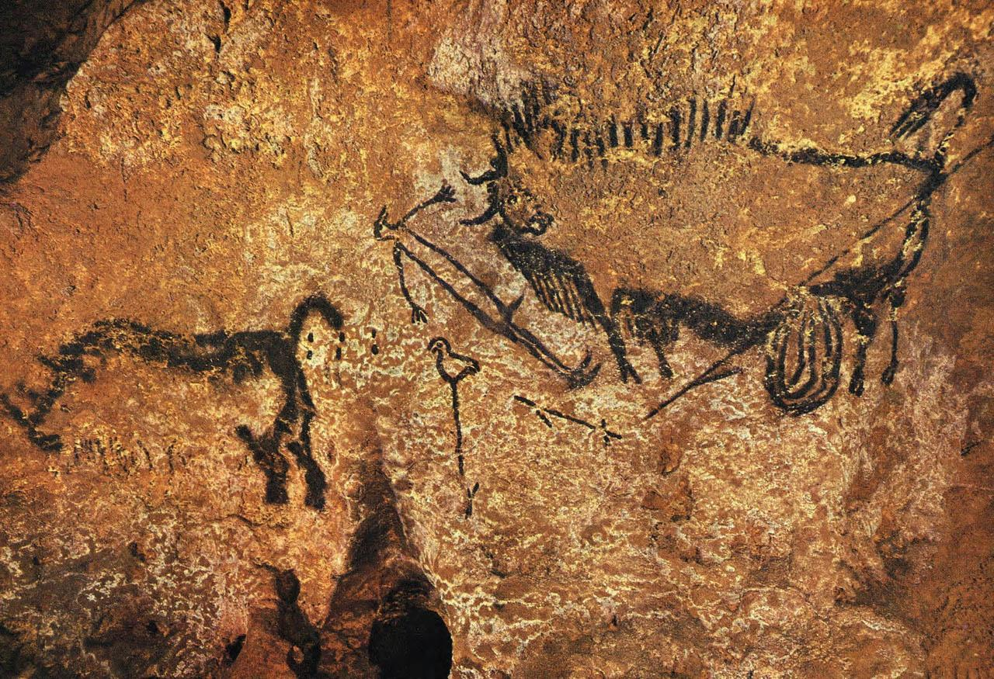

|  |
| --- |
| Extra Information (Extra Credit): |

14)

|  |
| --- |
| Extra Information (Extra Credit): |

15)

|  |
| --- |
| Extra Information (Extra Credit): |

16)

|  |
| --- |
| Extra Information (Extra Credit): |



17)

|  |
| --- |
| Extra Information (Extra Credit): |

18)

|  |
| --- |
| Extra Information (Extra Credit): |

19)

|  |
| --- |
| Extra Information (Extra Credit): |



20)

|  |
| --- |
| Extra Information (Extra Credit): |

21)

|  |
| --- |
| Extra Information (Extra Credit): |

22)

|  |
| --- |
| Extra Information (Extra Credit): |

23)

|  |
| --- |
| Extra Information (Extra Credit): |

24)

|  |
| --- |
| Extra Information (Extra Credit): |

25)

|  |
| --- |
| Extra Information (Extra Credit): |

**Part 3 – Compare & Contrast Essay:**

Instructions: In the space provided, discuss the similarities and differences between these two images in short 4-6 sentence paragraphs.

26) 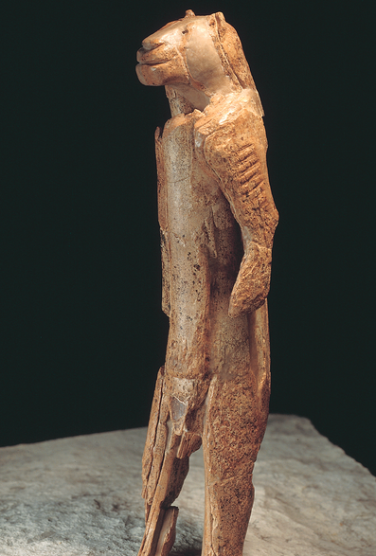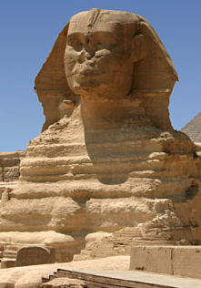

|  |
| --- |
| Explain the similarities and differences between cultures & time periods associated with these artworks: |
| Explain how these differences have affected the artworks pictured above: |

27)

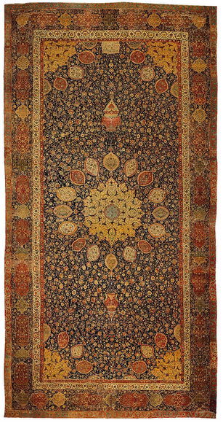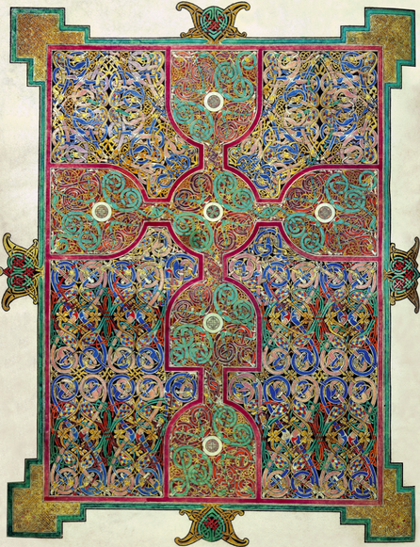

|  |
| --- |
| Explain the similarities and differences between cultures & time periods associated with these artworks: |
| Explain how these differences have affected the artworks pictured above: |